AIM :

PROGRAM

import pandas as pd

import matplotlib.pyplot as plt

import tensorflow as tf

from tensorflow import keras

np.random.seed(42)

# tf.set.random. seed(42)

fashion_mnist = keras.datasets.fashion_mnist

(X_train, y_train), (X_test, y_test) = fashion_mnist.load_data()

print(X_train.shape, X_test.shape)

X_train = X_train / 255.0

X_test = X_test / 255.0

plt.imshow(X_train[1], cmap='binary')

plt.show()

np.unique(y_test)

class_names = ['T-Shirt/Top", Trouser', 'Pullover', 'Dress', 'Coat', 'Sandal', 'Shirt', 'Sneaker', '8ag', 'Ankle Boot']

n_rows = 5

n_cols = 10

plt.figure(figsize=(n_cols * 1.4, n_rows * 1.6))

for row in range(n_rows):

for col in range(n_cols):

index = n_cols * row + col

plt.subplot(n_rows, n_cols, index + 1)

plt.imshow(X_train[index], cmap='binary', interpolation='nearest')

plt.axis('off')

plt.title(class_names[y_train[index]])

plt.show()

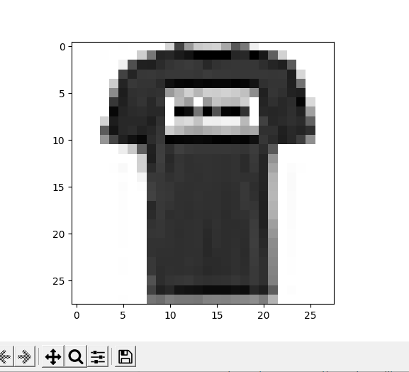

(60000, 28, 28) (10000, 28, 28)

